Kamala Harris
THE VICE PRESIDENT

Fighting For The People and Delivering For America.
Download Official Portrait
Kamala D. Harris is the Vice President of the United States. She always fights for the people – from her barrier-breaking time as District Attorney of San Francisco and Attorney General of California, to proudly serving as a United States Senator and the Vice President.
On January 20, 2021, Kamala Harris was sworn in as Vice President – the first woman, the first Black American, and the first South Asian American to be elected to this position.
As Vice President, she has worked to bring people together to advance opportunity, deliver for families, and protect fundamental freedoms across the country. She has led the fight for the freedom of women to make decisions about their own bodies, the freedom to live safe from gun violence, the freedom to vote, and the freedom to drink clean water and breathe clean air. While making history at home, she is also representing the nation abroad – embarking on more than a dozen foreign trips, traveling to more than 19 countries, and meeting with more than 150 world leaders to strengthen critical global alliances.
The Vice President has been a trusted partner to President Joe Biden as they work together to deliver monumental achievements that are lifechanging for millions of Americans. Together, they have invested in the economy to create a record number of jobs and keep unemployment low. Their work has led to more small business creation in a two-year period than any previous administration.
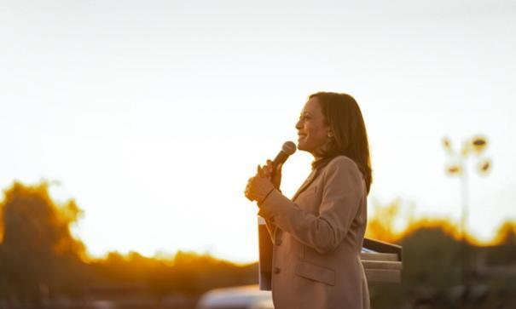
Vice President Harris speaking at an event
They capped the cost of insulin at $35 a month for seniors, cut prescription prices, and improved maternal health by expanding postpartum care through Medicaid. They passed the first meaningful gun safety law in three decades. Forming a bipartisan coalition, they enacted a $1 trillion investment in the country’s infrastructure to remove every lead pipe in America and make the most significant investment in public transit, repairing bridges, and high-speed Internet in history.
As President of the Senate, Vice President Harris set a new record for the most tie-breaking votes cast by a Vice President in history – surpassing a record that had stood for nearly 200 years. And her votes have been consequential. This includes casting the decisive vote to secure passage of the landmark Inflation Reduction Act, the largest investment ever in tackling the climate crisis. She also presided over the unprecedented vote to confirm the first Black woman, Justice Ketanji Brown Jackson, to the Supreme Court while working alongside President Biden to achieve historic representation of women and people of color among nominees at all levels of the federal government.
““At every step of the way, I've been guided by the words I spoke from the first time I stood in a courtroom: Kamala Harris, For the People.” - Kamala Harris, August 19, 2020

Fighting for the people is nothing new for Vice President Kamala Harris.
In 2017, she was sworn into the United States Senate where she championed legislation to fight hunger, provide rent relief, improve maternal health care, expand access to capital for small businesses, revitalize America’s infrastructure, and combat the climate crisis. She questioned two Supreme Court nominees while serving on the Judiciary Committee. She also worked to keep the American people safe from foreign threats and crafted bipartisan legislation to assist in securing American elections while serving on the Senate Select Committee on Intelligence.
In 2010, Vice President Harris was elected Attorney General of California where she oversaw the largest state justice department in the country. She took on those who were preying on the American people, winning a $20 billion settlement for Californians whose homes had been foreclosed on and a $1.1 billion settlement for students and veterans who were taken advantage of by a for-profit education company. She also defended the Affordable Care Act in court and enforced environmental laws.
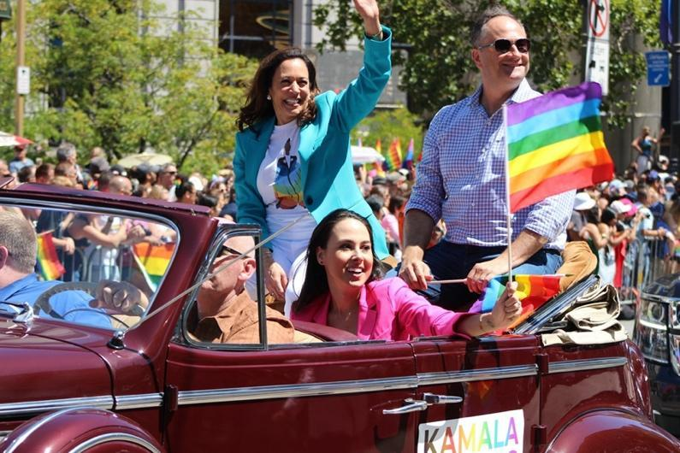
Vice President Harris at the Pride Parade in San Francisco, California
In 2004, Vice President Harris was elected District Attorney of San Francisco where she was a national leader in the movement for LGBTQ+ rights, officiating the first same-sex wedding after Proposition 8 was overturned. She also established the office’s environmental justice unit and created a ground-breaking program to provide first-time drug offenders with the opportunity to earn a high school degree and find employment, which the U.S. Department of Justice designated as a national model of innovation for law enforcement. And years earlier, in 1990, she joined the Alameda County District Attorney’s Office where she specialized in prosecuting child sexual assault cases.
Vice President Harris was born in Oakland, California. As the daughter of immigrants, she grew up surrounded by a diverse community and a loving extended family. She and her sister, Maya, were inspired by their mother, Shyamala Gopalan, a breast cancer scientist and pioneer in her own right who came to the United States from India at the age of 19 and then received her doctorate the same year that Kamala was born.
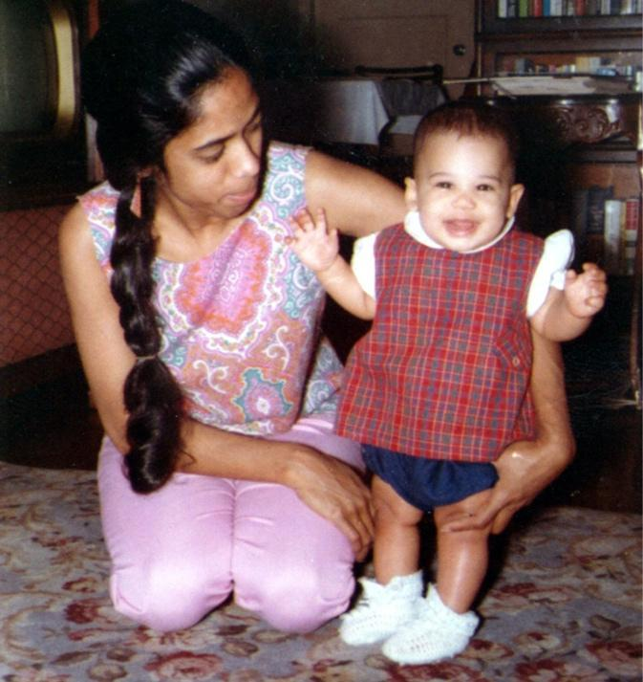
Vice President Harris with her mother, Shyamala

Both of the Vice President’s parents were active in the civil rights movement, and instilled in her a commitment to build strong coalitions that fight for the rights and freedoms of all people. They brought her to civil rights marches in a stroller and taught her about heroes like Supreme Court Justice Thurgood Marshall and civil rights leader Constance Baker Motley.
Vice President Harris went on to graduate from Howard University and the University of California Hastings College of Law. In 2014, she married Douglas Emhoff, a lawyer. They have a large blended family that includes their children, Ella and Cole.
As a trailblazer throughout her entire career, the Vice President is committed to fulfilling her mother’s advice: “Kamala, you may be the first to do many things, but make sure you are not the last.”
Vice President Harris embraces a young supporter.

